EDUCATIONAL CONSTRUCTION

St. Thomas Aquinas Church and School Addition
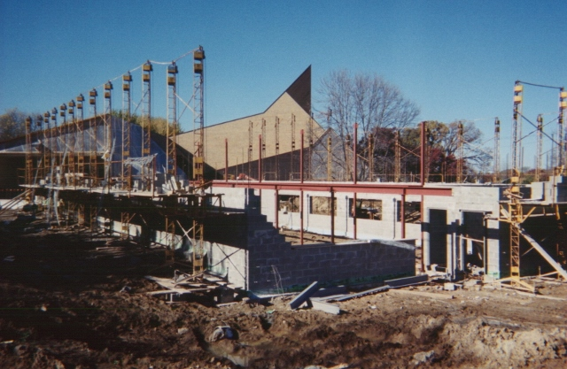Array
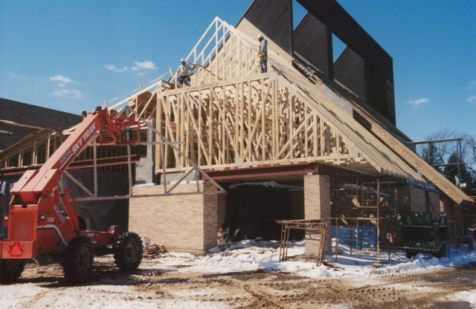Array
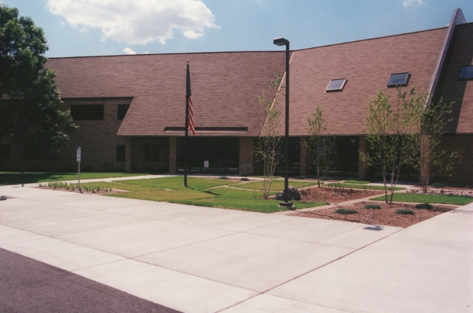Array
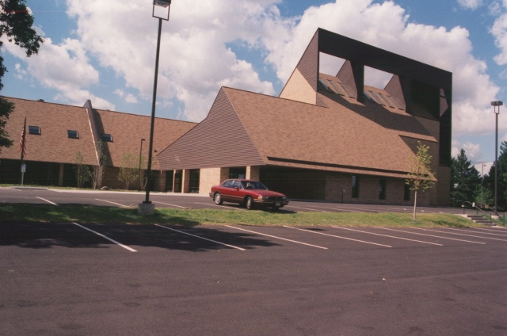Array

RPS STRUCTURAL ENGINEERING, LLC © 2023

